**1365. How Many Numbers Are Smaller Than the Current Number**

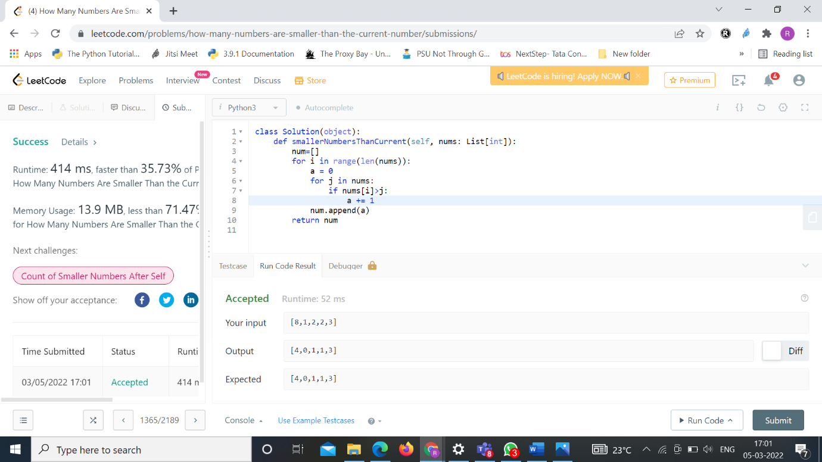

**283. Move Zeroes**

